***Figures and tables***

*Figure 1.1 – M&As Worldwide*

*Source: IMAA Institute, 2024*

*Figure 1.2 – Global M&A Operations by Sector*

*Source: Levy, 2025*

*Figure 1.3 – Global Strategic M&A Activity by Region*

*Source: Bain & Company, 2024*

*Figure 1.4 – Quarterly Breakdown of M&A Activity in Europe*

*Source: S&P Global, 2025*

*Figure 1.5 – Cumulative Abnormal Returns Around Event Date by News Type*

*Source: MacKinlay, 1997*

*Figure 1.6 – Event Study Timeline*

*Source: MacKinlay, 1997*

*Table 1.1 - Summary of Empirical Evidence on Determinants of Value Creation in M&A*

|  |  |  |  |  |  |  |
| --- | --- | --- | --- | --- | --- | --- |
| Determinant | Effect on Acquiror CARs | Effect on Target CARs | Evidence Strength (Acquiror) | Evidence Strength (Target) | Key References |  |
| Method of payment | Stock ↓ /Cash↑ | Cash↑ | High | High | Andrade et al. (2001); Boone et al. (2014); Loughran & Vijh (1997); Moeller et al. (2004); Travlos (1987) | (1) |
| Governance Quality | Strong ↑ | – | High | – | Harford, Humphery-Jenner & Powell (2012); Masulis, Wang & Xie (2007) | (2) |
| Relative Target Size | High relative size ↓/ ↑ (nonlinear) | – | Mixed | – | Asquith et al. (1983); Jarrell & Poulsen (1989); Loderer & Martin (1990); Moeller et al. (2004); Schwert (2000) | (3) |
| Deal Size / Acquiror Size | Large deals or large  acquirors ↓/↑ | – | Mixed | – | Alexandridis et al. (2017); Demsetz & Lehn (1985); Gorton et al. (2009) | (4) |
| Acquiror Leverage | Moderate ↑ / Excessive ↓ | – | Mixed | – | Dimitrov & Jain (2008); Maloney et al. (1993); Rau & Vermaelen (1998); Uysal (2011) | (5) |
| Premium Price | High premium ↓ (but may signal synergies) ↑ | High premium ↑ | Mixed | High | Antoniou et al. (2008); Hayward & Hambrick (1997); Moeller & Schlingemann (2005); Roll (1986) | (6) |
| Industry Relatedness | Related deals ↑ (but may lead to overpayment) ↓ | Related deals ↑ | Mixed | Moderate | Elgers & Clark (1980); Lubatkin (1987); Seth (1990); Shelton (1988); Singh & Montgomery (1987); Rose et al. (2017) | (7) |
| Domestic vs. Cross-Border | Domestic ↑ / Cross-border ↓ (but context-dependent) | Domestic ↑ | Mixed/not  conclusive | Moderate | Ahern et al. (2015); Eckbo & Thorburn (2000); Hazelkorn et al. (2004); Martynova & Renneboog (2008b); Rose et al. (2017) | (8) |

*Notes:*

1. Payment method affects market perception: stock deals often generate negative returns due to perceived overvaluation, while cash offers are seen as signals of confidence and financial discipline. This positive effect is stronger in uncertain contexts and for smaller acquirors. Recent trends confirm a shift away from stock-based deals toward cash or mixed structures, reflecting market preference;
2. Strong governance structures (e.g., independent boards, institutional ownership) enhance discipline and reduce agency problems, leading to higher CAR. Effective governance limits managerial discretion, reduces overpayment risk and enhances post-deal accountability, especially in large or complex transactions;
3. The effect of deal size and relative target size on acquiror returns is nonlinear and context dependent. Disproportionately large targets may trigger negative market reactions due to perceived risk, overpayment and integration challenges. However, in some cases, they signal strategic ambition and value creation;
4. Large deals often underperform. Smaller acquirors tend to perform better, as stronger ownership alignment limits agency problems and improves market confidence;
5. Leverage influences acquiror returns in a nonlinear way. Moderate debt levels can enhance deal quality by imposing financial discipline and limiting managerial overreach. However, excessive leverage may raise concerns about post-merger risk, integration challenges and limited strategic flexibility, especially in complex deals. In general, market reaction is more favourable when leverage is combined with focused, cash-financed acquisitions;
6. The effect of premium size on acquiror returns is debated. High premiums are often viewed as signs of managerial *hubris* and overconfidence, tending to trigger negative market reactions. However, when justified by credible synergy expectations, they may be interpreted positively. In contrast, target firms consistently benefit from higher premiums, which translate into significantly higher announcement returns for targets, especially in public deals;
7. Related deals may create operational synergies and boost CARs due to perceived operational fit but may also lead to overpayment when synergies are overestimated. Some evidence, instead, suggests that diversifying acquisitions can outperform focused ones, indicating that the effect is context-specific and not uniformly positive;
8. The impact of geographic scope on short-run value creation remains mixed and generally inconclusive. Domestic deals often benefit from local knowledge and smoother integration, resulting in higher returns. However, cross-border acquisitions may offer strategic advantages such as market expansion and access to foreign capabilities, despite greater cultural distance and operational complexity. Results vary across regions and deal characteristics.

*Figure 1.7 – Discriminative Ability of AI Evaluators*

*Source: Mirzayev et al., 2025*

*Figure 2.1 – Number of M&A Deals per Year*

*Source: Author’s elaboration*

*Figure 2.2 – Number of M&A Deals by Acquiror 2-digit SIC Sector*

*Source: Author’s elaboration*

*Figure 2.3 – Number of M&A Deals by Target 2-digit SIC Sector*

*Source: Author’s elaboration*

*Figure 2.4 – Share of M&A Deals by Acquiror and Target Country (≥1%)*

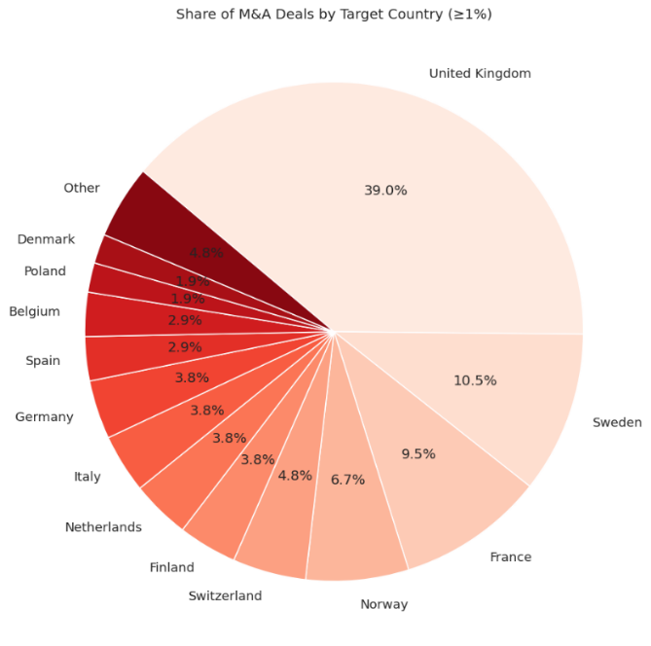

*Source: Author’s elaboration*

*Figure 2.5 – Distribution of Deal Value (Logarithmic Scale)*

*Source: Author’s elaboration*

*Figure 2.7 – Average Deal Value by Acquiror Industry and Country*

*Source: Author’s elaboration*

*Figure 2.8 – Average Deal Value by Target Industry and Country*

*Source: Author’s elaboration*

*Figure 2.9 – Number of M&A Deals by Acquiror Industry and Country*

*Source: Author’s elaboration*

*Figure 2.10 – Number of M&A Deals by Target Industry and Country*

*Source: Author’s elaboration*

*Table 2.1 – Acquiring Firms’ Statistics*

|  |  |  |  |  |  |  |  |
| --- | --- | --- | --- | --- | --- | --- | --- |
|  |  |  |  |  | **Significance level** | | |
| **Event Window** | **Mean** | **Std. Dev.** | **t-stat** | **p-value** | **10%** | **5%** | **1%** |
| (–1, +1) | -0.0160 | 0.0641 | -2.5504 | 0.0122 | Yes | Yes | No |
| (–3, +3) | -0.0187 | 0.0721 | -2.6515 | 0.0093 | Yes | Yes | Yes |
| (–5, +5) | -0.0218 | 0.0760 | -2.9395 | 0.0041 | Yes | Yes | Yes |
| (–10, +10) | -0.0195 | 0.0917 | -2.1790 | 0.0316 | Yes | Yes | No |

*Source: Author’s elaboration*

*Figure 2.11 – Positive CARs (%) by Event Window (Acquiring Firms)*

*Source: Author’s elaboration*

*Table 2.2 – Target Firms’ Statistics*

|  |  |  |  |  |  |  |  |  |
| --- | --- | --- | --- | --- | --- | --- | --- | --- |
|  |  |  |  | |  | **Significance level** | | |
| **Event Window** | **Mean** | **Std. Dev.** | | **t-stat** | **p-value** | **10%** | **5%** | **1%** |
| (–1, +1) | 0.17580 | 0.15390 | 11.70526 | | 1.08E-20 | Yes | Yes | Yes |
| (–3, +3) | 0.19045 | 0.16634 | 11.73190 | | 9.39E-21 | Yes | Yes | Yes |
| (–5, +5) | 0.19384 | 0.16890 | 11.75991 | | 8.15E-21 | Yes | Yes | Yes |
| (–10, +10) | 0.20360 | 0.19517 | 10.68907 | | 1.94E-18 | Yes | Yes | Yes |

*Source: Author’s elaboration*

*Figure 2.12 – Positive CARs (%) by Event Window (Target Firms)*

*Source: Author’s elaboration*

*Table 2.3 – Total CAR Statistics*

|  |  |  |  |  |  |  |  |
| --- | --- | --- | --- | --- | --- | --- | --- |
|  |  |  |  |  | **Significance level** | | |
| **Event Window** | **Mean** | **Std. Dev.** | **t-stat** | **p-value** | **10%** | **5%** | **1%** |
| (–1, +1) | 0.0214 | 0.0627 | 3.5024 | 0.0007 | Yes | Yes | Yes |
| (–3, +3) | 0.0206 | 0.0707 | 2.9944 | 0.0034 | Yes | Yes | Yes |
| (–5, +5) | 0.0181 | 0.0738 | 2.5111 | 0.0136 | Yes | Yes | No |
| (–10, +10) | 0.0221 | 0.0861 | 2.6356 | 0.0097 | Yes | Yes | Yes |

*Source: Author’s elaboration*

*Figure 2.13 – Distribution of Total CAR by Event Window*

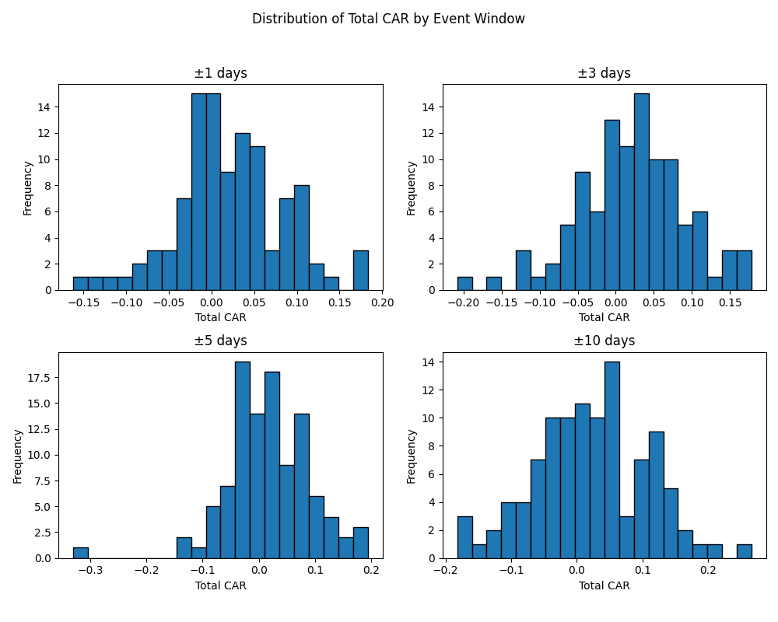

*Source: Author’s elaboration*

*Figure 2.14 – Positive Total CARs (%) by Event Window*

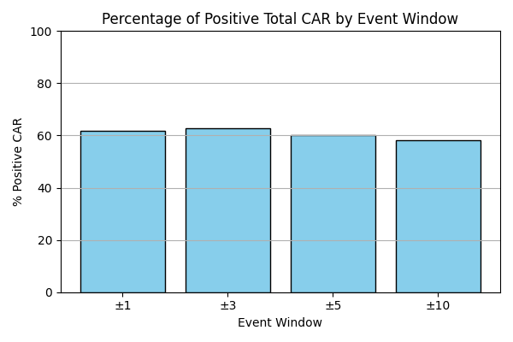

*Source: Author’s elaboration*

*Figure 2.15 – Distribution of Multi-Agent Prediction*

*Source: Author’s elaboration*

*Figure 2.16 – Structure of the LLM-Based Multi-Agent Decision Process*

*Source: Author’s elaboration*

*Table 3.1 - Logistic Regression Results*

|  |  |  |  |  |  |  |
| --- | --- | --- | --- | --- | --- | --- |
| **Variable** | **Estimate (β)** | **Std. Error** | **z-value** | **p-value** | **Odds Ratio (+0.01)** | **95% CI (OR)** |
| Intercept | – 5.049 | 2.125 | -2.376 | 0.01752 ** | – | – |
| Prediction | 8.277 | 2.838 | 2.917 | 0.00353 *** | 1.086 | (1.0275, 1.1484) |

|  |  |
| --- | --- |
| **Model diagnostics** |  |
| **McFadden’s R²** | 0.128 |
| **Likelihood Ratio Test (p-value)** | 0.0229 |
| **Residual Deviance** | 120.76 |
| **AIC** | 138.76 |
| **AUC (Area Under the ROC Curve)** | 0.734 |
| **N** | 105 |

***Notes:*** *The table reports logit regressions on an indicator variable that equals 1 if the total CAR over the window [-3,3] is greater than 0. Year fixed effects are included. p < .1; ** p < .05; *** p < .01.*

*Source: Author’s elaboration*

*Figure 3.1 – Effect of Prediction on CAR Positive Probability*

*Source: Author’s elaboration*

*Figure 3.2 – Discriminative Ability of the Model: ROC Curve*

*Source: Author’s elaboration*

*Figure 3.3 – Distribution of Predicted Probabilities by CAR Class*

*Source: Author’s elaboration*

*Figure 3.4 – Confusion Matrix*

*Source: Author’s elaboration*

*Table 3.2 – Confusion Matrix: Summary Statistics*

|  |  |
| --- | --- |
| **Metric** | **Value** |
| **Accuracy** | 0.7238 |
| **95% CI** | (0.628, 0.8066) |
| **No Information Rate** | 0.6286 |
| **P-Value [Acc > NIR]** | 0.02572 |
| **Kappa** | 0.4295 |
| **McNemar's Test P-Value** | 0.26521 |
| **Sensitivity** | 0.7273 |
| **Specificity** | 0.7179 |
| **Positive Predictive Value** | 0.8136 |
| **Negative Predictive Value** | 0.6087 |
| **Prevalence** | 0.6286 |
| **Detection Rate** | 0.4571 |
| **Detection Prevalence** | 0.5619 |
| **Balanced Accuracy** | 0.7226 |
| **Positive Class** | 1 |

*Source: Author’s elaboration*

*Table 3.3 - Shareholder Gains for Promising and Non-Promising M&A Portfolios as Identified by AI*

|  |  |  |  |  |  |
| --- | --- | --- | --- | --- | --- |
| ***Panel A*** | **Mean if prediction multi-agent ≤ Q2** | **Mean if prediction multi-agent > Q2** | **Difference** | **Std. error** | **t-value** |
| ***Percentage gains:*** |  |  |  |  |  |
| Total CAR | 0.002 | 0.042 | 0.041 | 0.018 | 2.165 |
| Acquiror CAR | -0.037 | 0.003 | 0.039 | 0.019 | 2.084 |
| Target CAR | 0.156 | 0.229 | 0.073 | 0.045 | 1.612 |
| ***Euro gains (€ mln):*** |  |  |  |  |  |
| Total CAR | 64.253 | 352.618 | 288.365 | 165.960 | 1.738 |
| Acquiror CAR | -76.958 | 5.903 | 82.861 | 113.527 | 0.729 |
| Target CAR | 144.815 | 356.066 | 211.251 | 140.823 | 1.500 |
|  |  |  |  |  |  |
| ***Panel B*** | **Mean if prediction multi-agent < Q1** | **Mean if prediction multi-agent > Q3** | **Difference** | **Std. error** | **t-value** |
| ***Percentage gains:*** |  |  |  |  |  |
| Total CAR | -0.017 | 0.047 | 0.065 | 0.024 | 2.726 |
| Acquiror CAR | -0.053 | 0.014 | 0.067 | 0.024 | 2.764 |
| Target CAR | 0.152 | 0.210 | 0.058 | 0.056 | 1.047 |
| ***Euro gains (€ mln):*** |  |  |  |  |  |
| Total CAR | 144.729 | 319.863 | 175.134 | 233.446 | 0.750 |
| Acquiror CAR | -98.073 | -36.068 | 62.0051 | 157.222 | 0.394 |
| Target CAR | 246.621 | 363.794 | 117.173 | 230.498 | 0.508 |

*Notes: The first two columns of the table report the means of total CAR, the acquiror’s CAR and the target’s CAR over the [-3,3] window for different groups of observations, both as a percentage and in million U.S. dollars. The dollar gains are computed by multiplying the CAR measure with the respective market capitalization six trading days before the announcement. Panel A splits observations based on the median (Q2) of prediction multi-agent. Panel B splits observations based on the bottom (Q1) and top (Q3) quartiles of prediction multi-agent. The last three columns report the difference in means, its standard error and the t-test of the difference, respectively.*

*Source: Author’s elaboration*

*Table 3.4 – Logistic Regressions: Incremental Value Analysis*

|  |  |  |  |
| --- | --- | --- | --- |
| Metric | Baseline Model (i) | Full Model  (ii) | Notes |
| Prediction coefficient | – | 12.039 | (1) |
| Likelihood Ratio Test (p-value) | – | 0.0035*** | (2) |
| Residual Deviance | 94.336 | 85.673 | (3) |
| AIC | 142.336 | 135.673 | (4) |
| McFadden’s R² | 0.283 | 0.349 | (5) |
| AUC (Area Under the ROC Curve) | 0.846 | 0.888 | (6) |
| Controls | Yes | Yes |  |
| Year FE | Yes | Yes |  |
| N | 105 | 105 |  |

***Notes:****This table compares the performance of two logistic regression models: one using only structured input variables (Baseline Model), and one including the predicted probability from the multi-agent LLM system (Full Model). Both models include control variables and year fixed effects, as specified in the methodology section. * p < .1; ** p < .05; *** p < .01.*

1. *Statistically significant (p = 0.0081)\*\*\**
2. *= 8.55 → significant improvement with the inclusion of LLM-based multi-agent prediction*
3. *Better alignment with observed outcomes*
4. *More efficient model specification*
5. *+ 0.065 → improved model fit*
6. *+ 0.047 → higher ability to distinguish outcomes*

*Source: Author’s elaboration*

*Table 3.6 – Ablation Study*

|  |  |  |  |  |  |  |
| --- | --- | --- | --- | --- | --- | --- |
| **Model Variant** | **Estimate** | **Std. Error** | **z-value** | **p-value** | **McFadden's** | **AUC** |
| Full Multi-Agent Model | 8.277 | 2.838 | 2.917 | 0.004*** | 0.128 | 0.734 |
| Macro-themes + Semantic | 5.211 | 2.329 | 2.248 | 0.025** | 0.085 | 0.664 |
| Empirical + Semantic | 4.887 | 2.118 | 2.301 | 0.042** | 0.097 | 0.675 |
| Empirical + Macro-themes | 5.025 | 2.136 | 2.340 | 0.038** | 0.100 | 0.678 |
| Empirical only | 2.254 | 1.448 | 1.549 | 0.120 | 0.065 | 0.640 |
| Macro-themes only | 2.102 | 1.347 | 1.451 | 0.168 | 0.054 | 0.627 |
| Semantic only | 1.956 | 1.389 | 1.418 | 0.174 | 0.052 | 0.625 |

*Notes: this table reports the results of multiple logistic regression models testing different configurations of the multi-agent prediction pipeline. The dependent variable is a binary indicator equal to 1 if the total CAR over the event window [–3, +3] is greater than 0. Each variant includes a distinct subset of the model’s internal reasoning components as input, while holding year fixed effects constant across all specifications. Controls are not included in the ablation study, as the objective is to isolate the contribution of each reasoning layer within the architecture itself. The full model includes semantic signals, macro-thematic cues and empirical associations. * p < .1; ** p < .05; *** p < .01.*

*Source: Author’s elaboration*

*Table 3.7 – Text Generalization Check*

|  |  |  |
| --- | --- | --- |
| **Metrics** | **Model with original anonymized text**  **(i)** | **Model with decontextualized anonymized text**  **(ii)** |
| **Intercept** | –5.049 | –3.904 |
| **Coefficient Prediction** | 8.277 | 6.842 |
| **p-value (Prediction)** | 0.0035*** | 0.0412** |
| **McFadden’s R²** | 0.128 | 0.119 |
| **Residual Deviance** | 120.76 | 104.710 |
| **AIC** | 138.76 | 150.809 |
| **Likelihood Ratio Test (p-value)** | 0.0023 | 0.0389 |
| **AUC** | 0.734 | 0.698 |

***Notes:*** *this table compares the predictive performance of the multi-agent model when applied to (i) original anonymized press releases and (ii) fully decontextualized versions of the same texts, in which any semantic reference to firm identity, sector or geography was removed. Both models use the same structured variables and reasoning logic, and both regressions include year fixed effects. Controls are excluded to isolate the effect of textual abstraction on predicted probability. * p < .1; ** p < .05; *** p < .01.*

*Source: Author’s elaboration*

*Table 3.8 - OLS Regressions for Total CAR (%)*

|  |  |  |  |  |  |
| --- | --- | --- | --- | --- | --- |
| **Variable** | **Estimate (β)** | **Std. Error** | **t-value** | **p-value** | **95% CI (β)** |
| **Intercept** | -0.171 | 0.058 | -2.955 | 0.004 | (–0.286, –0.056) |
| **Prediction** | 0.277 | 0.075 | 3.693 | < 0.001 | (0.128, 0.426) |

|  |  |
| --- | --- |
| **Model diagnostics** |  |
| **R-squared** | 0.184 |
| **Adjusted R-squared** | 0.115 |
| **F-statistic** | 2.697 on 8 and 96 DF |
| **p-value (overall model)** | 0.0101** |
| **RMSE** | 0.0635 |
| **MAE** | 0.0499 |
| **N** | 105 |

*Notes: The table reports OLS regressions on total CAR over the window [-3,3], expressed as a percentage. Year fixed effects are included. p < .1; ** p < .05; *** p < .01.*

*Source: Author’s elaboration*

*Figure 3.5 - Linear Relationship Between Prediction and CAR*

*Source: Author’s elaboration*

*Figure 3.6 – OLS Regression Diagnostics Plots*

*Source: Author’s elaboration*

*Table 3.9 - OLS Regressions for Total CAR (%): Incremental Value Analysis*

|  |  |  |  |  |  |  |  |
| --- | --- | --- | --- | --- | --- | --- | --- |
|  | **(1)** | **(2)** | **(3)** | **(4)** | **(5)** | **(6)** | **(7)** |
| **Prediction multi-agent** | 0.289 | — | 0.231 | — | 0.390 | — | 0.460 |
| **p-value** | 0.000*** | — | 0.010** | — | 0.016** | — | 0.012** |
| **Std. Err.** | 0.072 | — | 0.084 | — | 0.163 | — | 0.191 |
| **Controls** | — | Yes | Yes | Yes | Yes | Yes | Yes |
| **Year FE** | — | Yes | Yes | Yes | Yes | Yes | Yes |
| **Acquiror industry FE** | — | — | — | Yes | Yes | — | Yes |
| **Target industry FE** | — | — | — | Yes | Yes | — | Yes |
| **Acquiror × Target FE** | — | — | — | — | — | Yes | Yes |
| **R²** | 0.136 | 0.355 | 0.409 | 0.770 | 0.830 | 0.825 | 0.833 |
| **Adj. R²** | 0.128 | 0.183 | 0.232 | 0.244 | 0.378 | 0.352 | 0.372 |
| **Within R²** | – | 0.330 | 0.386 | 0.526 | 0.525 | 0.541 | 0.522 |
| **N** | 105 | 105 | 105 | 75 | 75 | 61 | 61 |

*Notes: The table reports OLS regressions on total CAR over the window [-3,3], expressed as a percentage. The list of control variables is described in the methodology section. FE: fixed effects. Industry FE are defined based on primary two-digit SIC codes. The number of observations (N) drops in models (4)-(7) due to singletons. * p < .1; ** p < .05; *** p < .01.*

*Source: Author’s elaboration*

*Table 3.10 - Logit Regressions for Positive Total CAR With Alternative Event Windows*

|  |  |  |  |  |  |  |  |
| --- | --- | --- | --- | --- | --- | --- | --- |
| **Event window** | **(0)** | **(-1, 0)** | **(0, +1)** | **(-1, +1)** | **(-5, +2)** | **(-2, +5)** | **(-5, +5)** |
| **Coef. (prediction)** | 6.667 | 7.841 | 16.467 | 14.309 | 6.516 | 6.977 | 7.301 |
| **p-value (prediction)** | 0.029** | 0.031** | 0.002*** | 0.002*** | 0.030** | 0.066* | 0.021** |
| **AIC** | 139.140 | 150.151 | 127.082 | 140.959 | 140.382 | 140.487 | 139.820 |
| **Log-Likelihood** | -45.570 | -51.076 | -39.541 | -46.479 | -46.191 | -46.243 | -44.910 |
| **McFadden R²** | 0.312 | 0.224 | 0.399 | 0.305 | 0.246 | 0.297 | 0.311 |
| **AUC** | 0.834 | 0.795 | 0.869 | 0.846 | 0.818 | 0.846 | 0.839 |
| **Controls** | Yes | Yes | Yes | Yes | Yes | Yes | Yes |
| **Year FE** | Yes | Yes | Yes | Yes | Yes | Yes | Yes |
| **N** | 105 | 105 | 105 | 105 | 105 | 105 | 105 |

*Notes: The table reports logit regressions on an indicator variable that equals 1 if the total CAR is greater than 0. Each model considers a different event window to measure total CAR. The list of control variables is described in the methodology section. FE: fixed effects. * p < .1; ** p < .05; *** p < .01.*

*Source: Author’s elaboration*

*Table 3.11 - Logit Regressions for Positive Total CAR: Different LLMs*

|  |  |  |  |  |  |  |
| --- | --- | --- | --- | --- | --- | --- |
| **LLM (multi-agent)** | **Estimate (β)** | **Std. Error** | **z-value** | **p-value** | **McFadden’s R²** | |
| **GPT- 4o** | 11.654 | 4.421 | 2.650 | 0.008*** | 0.337 |
| **Claude 3.5 Sonnet** | 10.020 | 5.202 | 1.933 | 0.054* | 0.295 |
| **Gemini 1.5 Pro** | 8.110 | 4.710 | 1.731 | 0.082* | 0.249 |

*Notes: The table reports logit regressions on an indicator variable that equals 1 if the total CAR over the window [-3,3] is greater than 0. All models include control variables and year fixed effects, as described in the methodology section. The LLM prediction measures are derived from GPT-4o, Gemini 1.5 Pro and Claude 3.5 Sonnet. * p < .1; ** p < .05; *** p < .01.*

*Source: Author’s elaboration*

*Figure 3.7 – Logistic Regression Curves for Different LLMs*

*Notes: The figure represents an illustrative comparison of the logistic curves derived from the models based on the three different LLMs (GPT‑4o, Claude 3.5 and Gemini 1.5). For visualization purposes, the prediction variable is normalized to the [0,1] interval to emphasize relative differences in slope and allow direct comparison across models.*

*Source: Author’s elaboration*

Appendix:

Empirical knowledge base:

where *WGI* is the *Worldwide Governance Indicators* (World Bank, 2024), constructed as the average of the six WGI sub-indices over the period 1996 to 2016 (immediately preceding sample’s empirical window of 2017–2024). The sub-indices are as follows:

* + - Control of Corruption
    - Government Effectiveness
    - Political Stability
    - Rule of Law
    - Regulatory Quality
    - Voice and Accountability

where denotes the **first two digits** of the SIC code.